**The laboratory work 10**

#### **OOP Exercise 1**: Create a Vehicle class with max_speed and mileage instance attributes

Refer:

* [Classes and Objects in Python](https://pynative.com/python-classes-and-objects/)
* [Instance variables in Python](https://pynative.com/python-instance-variables/)

#### **OOP Exercise 2**: Create a Vehicle class without any variables and methods

#### **OOP Exercise 3**: Create a child class Bus that will inherit all of the variables and methods of the Vehicle class

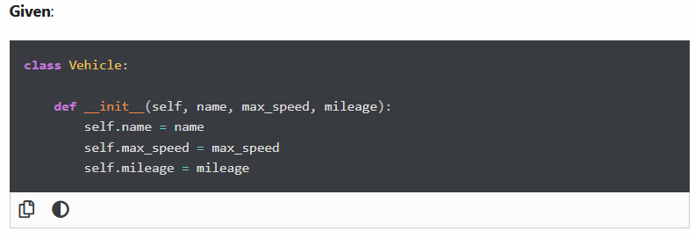

Create a Bus object that will inherit all of the variables and methods of the Vehicle class and display it.

#### **OOP Exercise 4**: Class Inheritance

**Given**:

Create a **Bus** class that inherits from the **Vehicle** class. Give the capacity argument of Bus.seating_capacity() a default value of 50.

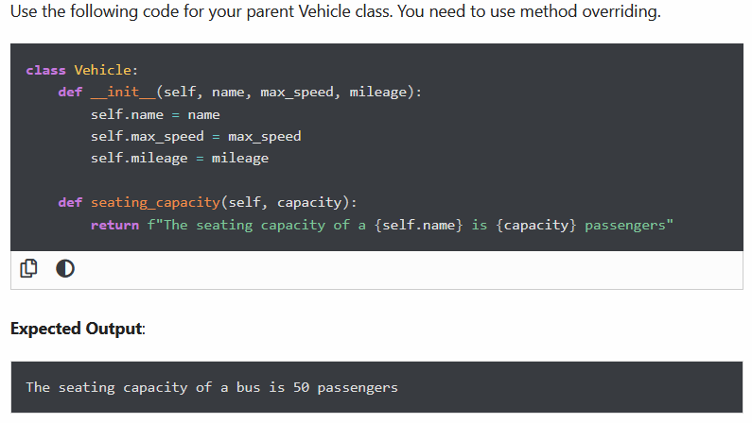

#### **OOP Exercise 5**: Define property that should have the same value for every class instance

Define a **class** attribute”**color**” with a default value **white**. I.e., Every Vehicle should be white.

Use the following code for this exercise.

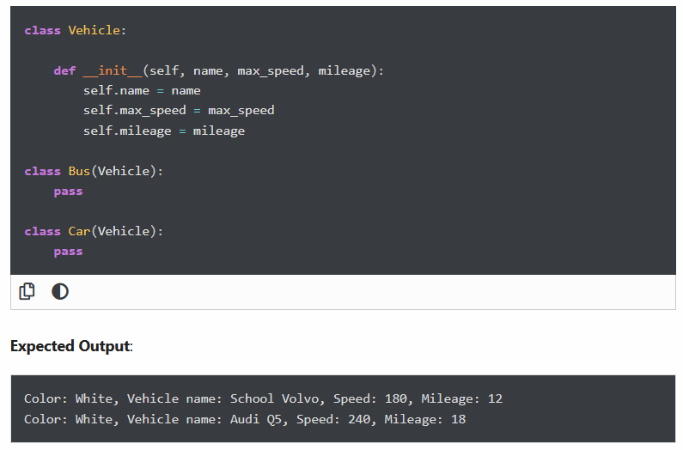

#### **OOP Exercise 6**: Class Inheritance

**Given**:

Create a **Bus** child class that inherits from the Vehicle class. The default fare charge of any vehicle is **seating capacity * 100**. If Vehicle is **Bus** instance, we need to add an extra 10% on full fare as a maintenance charge. So total fare for bus instance will become the **final amount = total fare + 10% of the total fare.**

Note: The bus seating capacity is **50**. so the final fare amount should be **5500.** You need to override the fare() method of a Vehicle class in Bus class.

Use the following code for your parent Vehicle class. We need to access the parent class from inside a method of a child class.

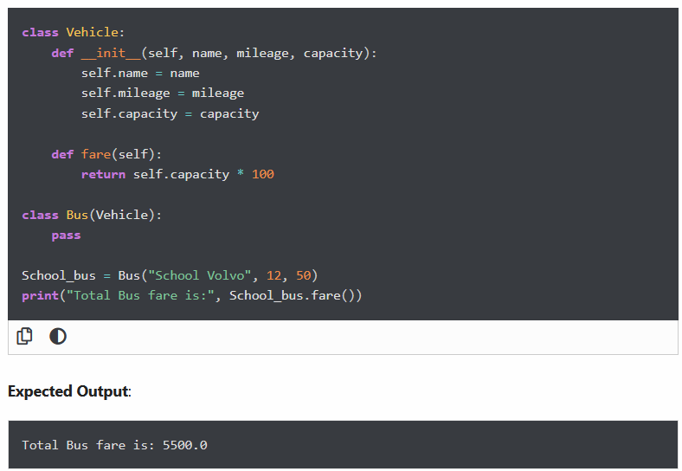

#### **OOP Exercise 7**: Determine which class a given Bus object belongs to (Check type of an object)

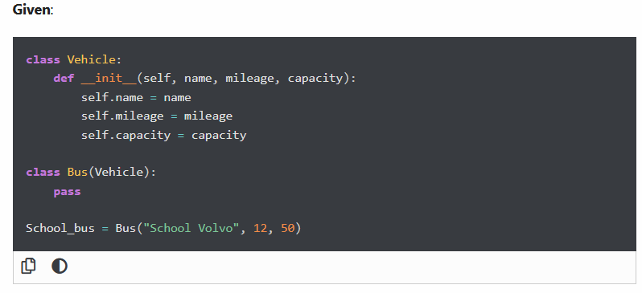

#### **OOP Exercise 8**: Determine if School_bus is also an instance of the Vehicle class

